Rakshya Gharti Magar
F r o n ten d D evel o p er

P R O F E S S I O N A L S U M M A R Y

+977 9763631696
C O N T A C T

Gulmi, Nepal rakshya.gm123@gmail.com
Motivated IT student with a strong foundation in HTML, CSS, JavaScript, and React.js. Passionate about building responsive and user-friendly web applications. Currently learning modern frontend development and eager to gain practical experience through internships and personal projects.

FRONTEND
E D U C A T I O N
T E C H N I C A L S K I L L S

HTML5 CSS3
JavaScript (ES6) React.js Tailwind CSS
TOOLS
Git

Everest Engineering College
Bachelor of Engineering in Information Technology
Pokhara University 2024 – Present

Kalika Manavgyan Secondary School 2022 – 2024
C E R T I F I C A T I O N S

GitHub VS Code
L A N G U A G E S

3-Month Computer Training Course
S O F T S K I L L S


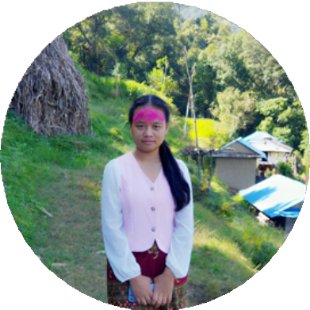

English Nepali
Problem Solving Teamwork
Quick Learner Communication

